Task 9

Database access
The vast majority of applications today take advantage of database technology to accomplish the more traditional data processing activities. Visual Basic provides the `Jet database engine` to facilitate easy data access to popular database file formats. These include:
- Access
- Btrieve
- dBase
- Excel
- FoxPro
- Lotus
- Paradox
- Text
- ODBC
- Others can be added

The features provided by the Jet database Engine is very impressive, it provides the application developer with a mechanism to create general data access, applications with ease and conversely the capability to directly control data access and achieve the most complicated operations.

While it is possible to build a pilot application with relative ease, it must be recognised that we are dealing with a very sophisticated tool. Developed to provide a vast range of features, and compete in the complex world of relational database management, we should expect to hit barriers if we become over ambitious.

Until you become familiar with the product, I advise the best way to build a data access application is to start by using the Data Control and DBGrid objects to gain simple access to a MS Access database, and then build any additional functionality one step at a time.

Form Design
To start create a new project in a new directory/folder. Name the project and form as appropriate.
- Identify an Access database, or create a new one, using Add-Ins menu, Data Manager.
- Place one Data control object on the form.
- Place one DBGrid object on the form and size it to fill the lower area.
- Set the DBGrid - DataSource property to identify your Data control.
- Set the Data control - Database Name property to identify your Access database.
- Set the record Source Type property to Table.
- Set the Record Source to your table name.
- The data access application should now function.

If you view existing records in the data grid / table you will find that you can update certain fields, but little else at this stage!

Code required to interact with databases
The data control object has a number of properties that determine the data that is controlled by the Data object. These are summarized in the table below:
Property | Sets database item | Comment
Databasename | Database file | Set by file dialog
RecordSource | Table of data | Will set from combo in properties
The data grid and bound data objects have the following properties.
Property | Sets database item | Comment
DataSource | Data control | Will set from combo in properties
Datafield | Column | Used to set which column of data is displayed from the data table linked by the data source. Set by the a combo in the object properties once the source is selected.

In order to append records to or delete records from the database table you need to set permission to do this. This achieved by setting DBGrid properties in code with:
DBGrid1.AllowAddNew = True
DBGrid1.AllowUpdate = True
DBGrid1.AllowDelete = True

This can be achieved by placing the above statement in the form load event, however it would be better to set-up command buttons or menu options to allow these to be enabled (True) and disabled (False).

You will find that the DBGrid/Data control will not save a record update unless you have explicitly moved off the record (Loss Focus) when you exit the application and it will not let you save a new record if a primary key or required index has an appropriated value.

If you create an index for your table you will find that you can set the Data control to access the record in sorted order:
Data1.Recordset.Index = IndexNameString

In addition you can use the index to search for key values:
Data1.Recordset.Seek “>=”, ValueString

The DBGrid/Data control objects are on the whole well behaved and ideal to create simple data handling applications, but as your requirements become more sophisticated, and you start using relational techniques you will need to abandon this approach and write code to achieve your objectives.

The Database table
A database is constructed form Tables of data and in order to understand the way in which Visual Basic is able to control the data from the database we will first look at the manner in which data is stored.
The example north-wind database contains the following set of tables.
Table | Contains | Linked relation to other table
Suppliers | Product suppliers | Supplier ID used in Products one to many
Categories | Product categories | Category ID used in Products one to many
Products | Product information | Product ID used in Order Details one to many
Employees | Employee information | Employee ID used in Orders one to many
Customers | Customer information | Customer ID used in Orders one to many
Shippers | Delivery company information | Shipper Id used in Orders one to many
Orders | Single order information | Order Id used in Order Details
Order Details | Contains multiple rows for each product and order number

Contents of each Table
Each table will contain different pieces of information there are principally three different data types that can be used for each column within a table. These are numbers, text, and OLE Objects. These different categories can be represented in many different ways. as follows.
Data type | Options | Contains | Visual Basic equivalent variable
Text, Memo, Hyperlink | Field Size | Characters | String
Number | Integer, long integer | Integer | Long, int
Number | Double, Single |  | Double and Single
Currency |  | Money values | Currency
Date/Time |  |  | Date
Autonumber | (No Duplicates) | Primary key Id index | Can vary
OLE Object |  | Object such as a picture
As with all data types there is a memory size implication for each type. These implications are similar to those for all computer language variables and also the accuracy of the values is similar to those of data variables.
The column data from the Category table is shown below. The columns include the CategoryID which is a Number used to index the table this value is a primary key (hence the icon of key in front of the column design information). The primary key value is used for storage in the products table. The products table then can be linked to the category be storing just the number. The relationship of this column is one to many. That is there will be only unique values of CategoryId stored in the Category table, and this value can be stored in many rows of the products table.
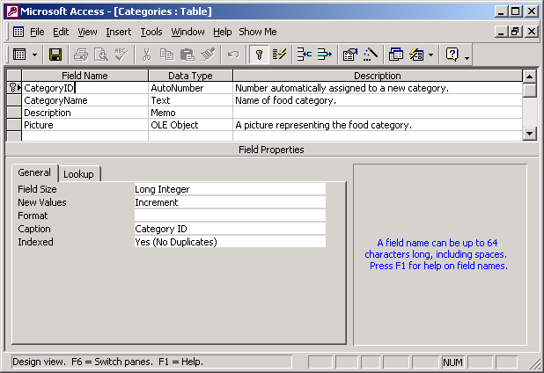

Database relationships.
The understanding relationship between a set of table is something that is not totally required to display a set of table data. But an understanding how the different data are related will help to understand how information can be then extracted into a user understandable form.
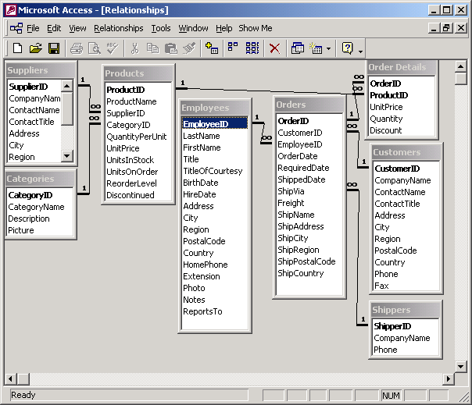

SQL Script selection
It is possible to use SQL select scripts to filter the items to be displayed from with in the data grids. Such as the SQL script that follows.
Select CompanyName, Contactname, Address from Suppliers where City = ‘London’

For more information on SQL script a good SQL reference book is recommendable.

